**GAURAV AMARNANI, D7A 67 OOPM.**

**Name: Gaurav Amarnani.**

**Roll No. 67, D7A.**

Practical 1: WAP to implement JOKER Face in applet.

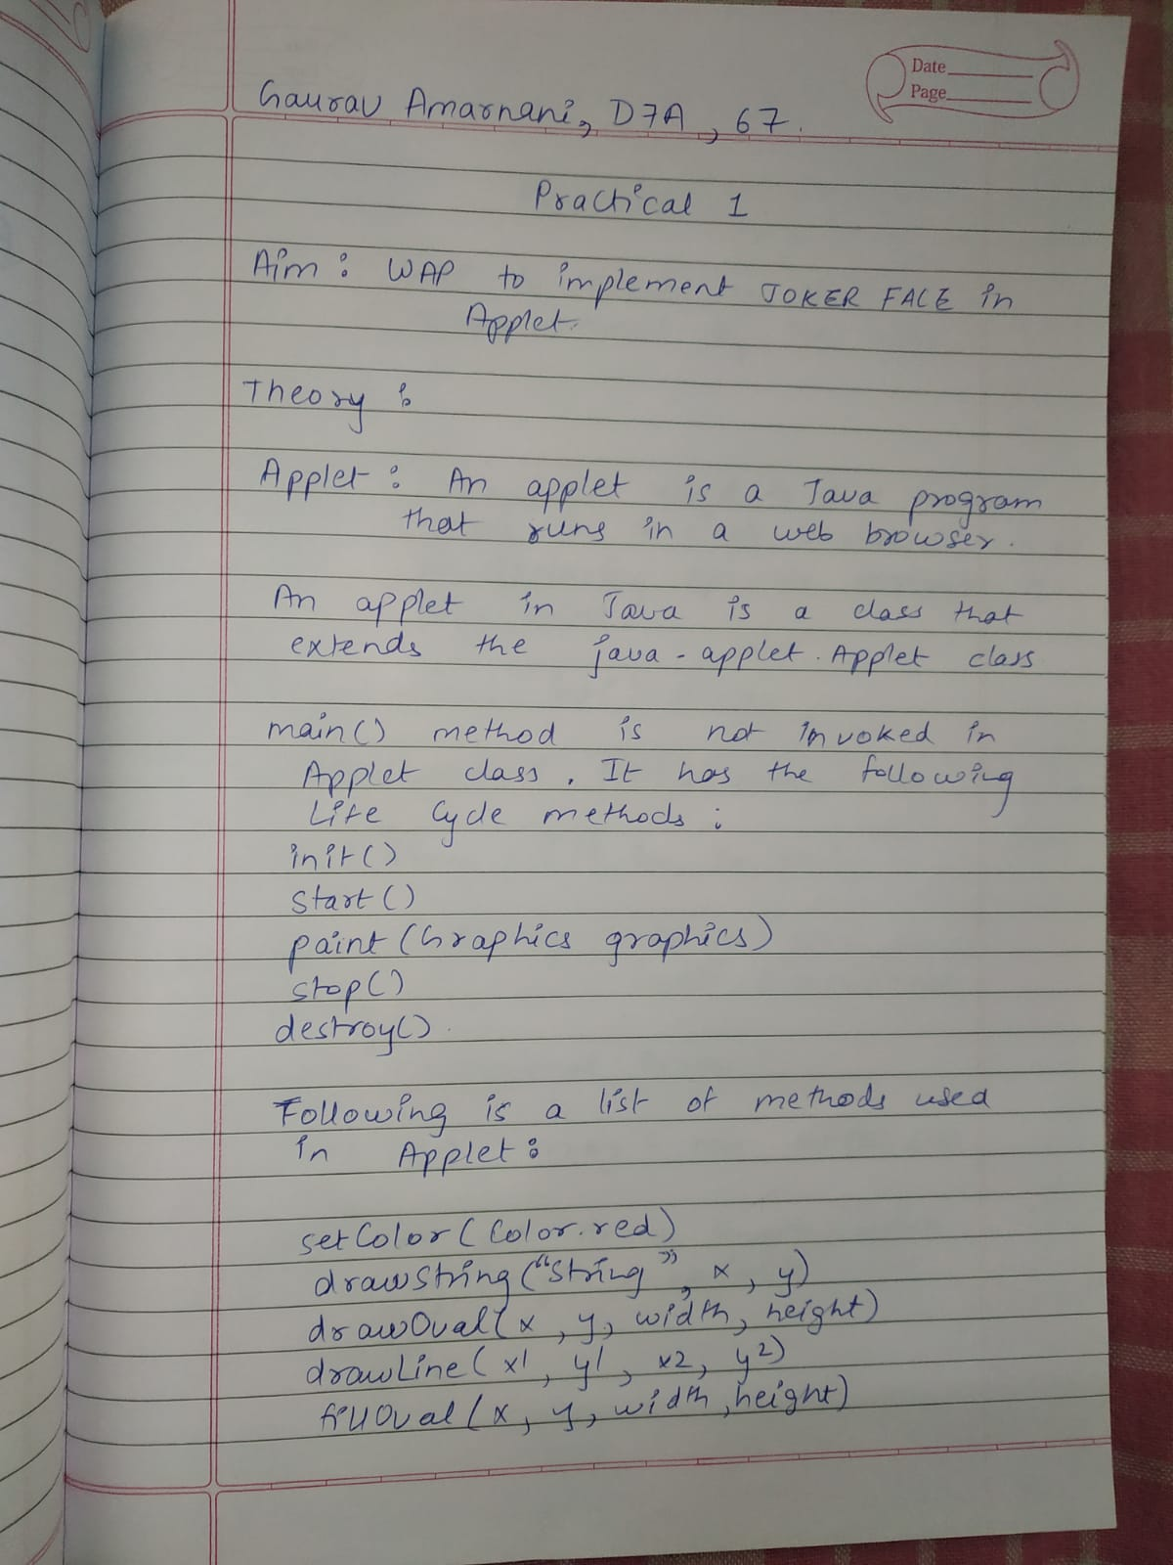

**Name: Gaurav Amarnani.**

**Roll No. 67, D7A.**

Program:

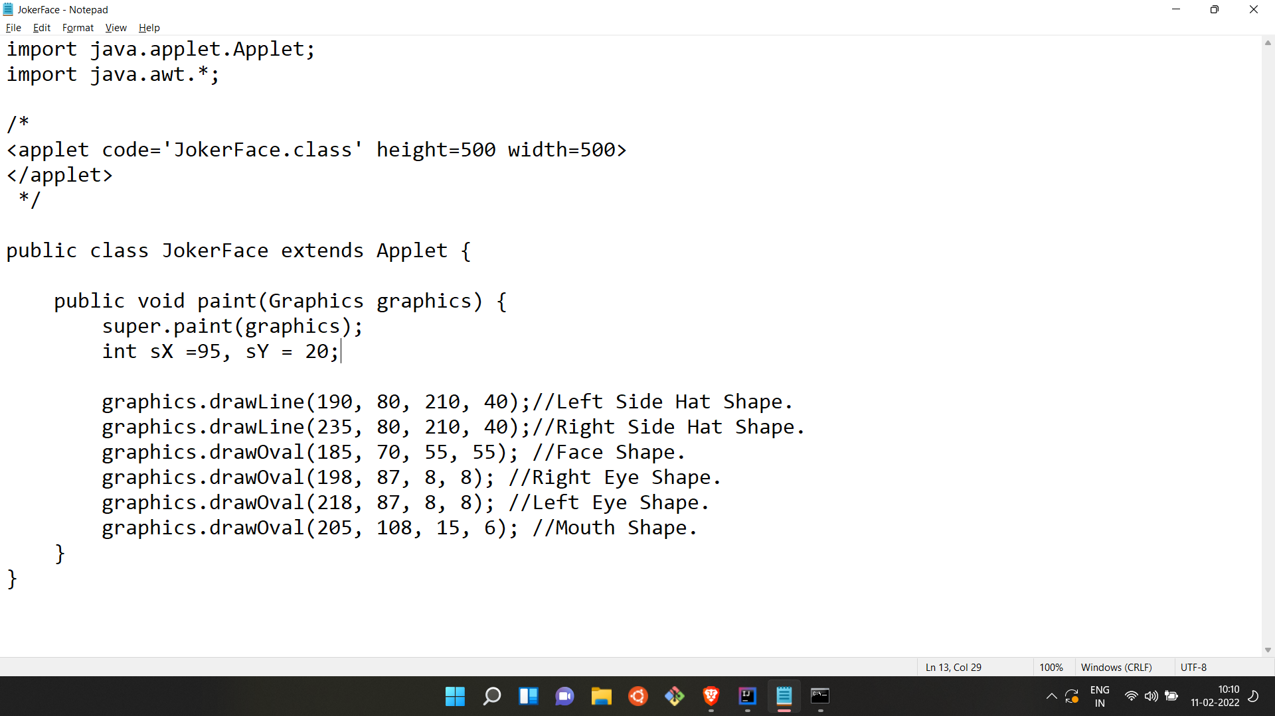

Output:

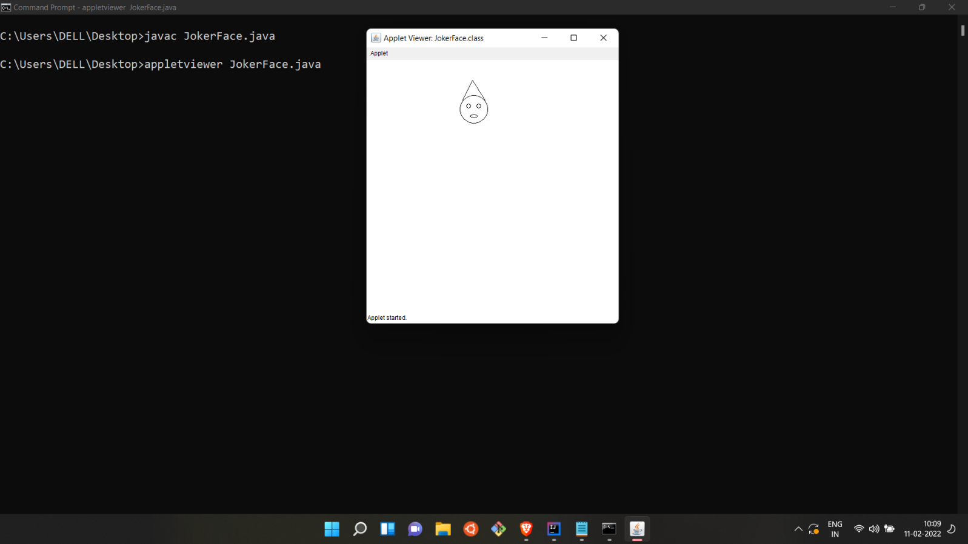

**GAURAV AMARNANI, D7A 67 OOPM.**

**Name: Gaurav Amarnani.**

**Roll No. 67, D7A.**

Practical 2: WAP to Search an element in an array entered by the user.

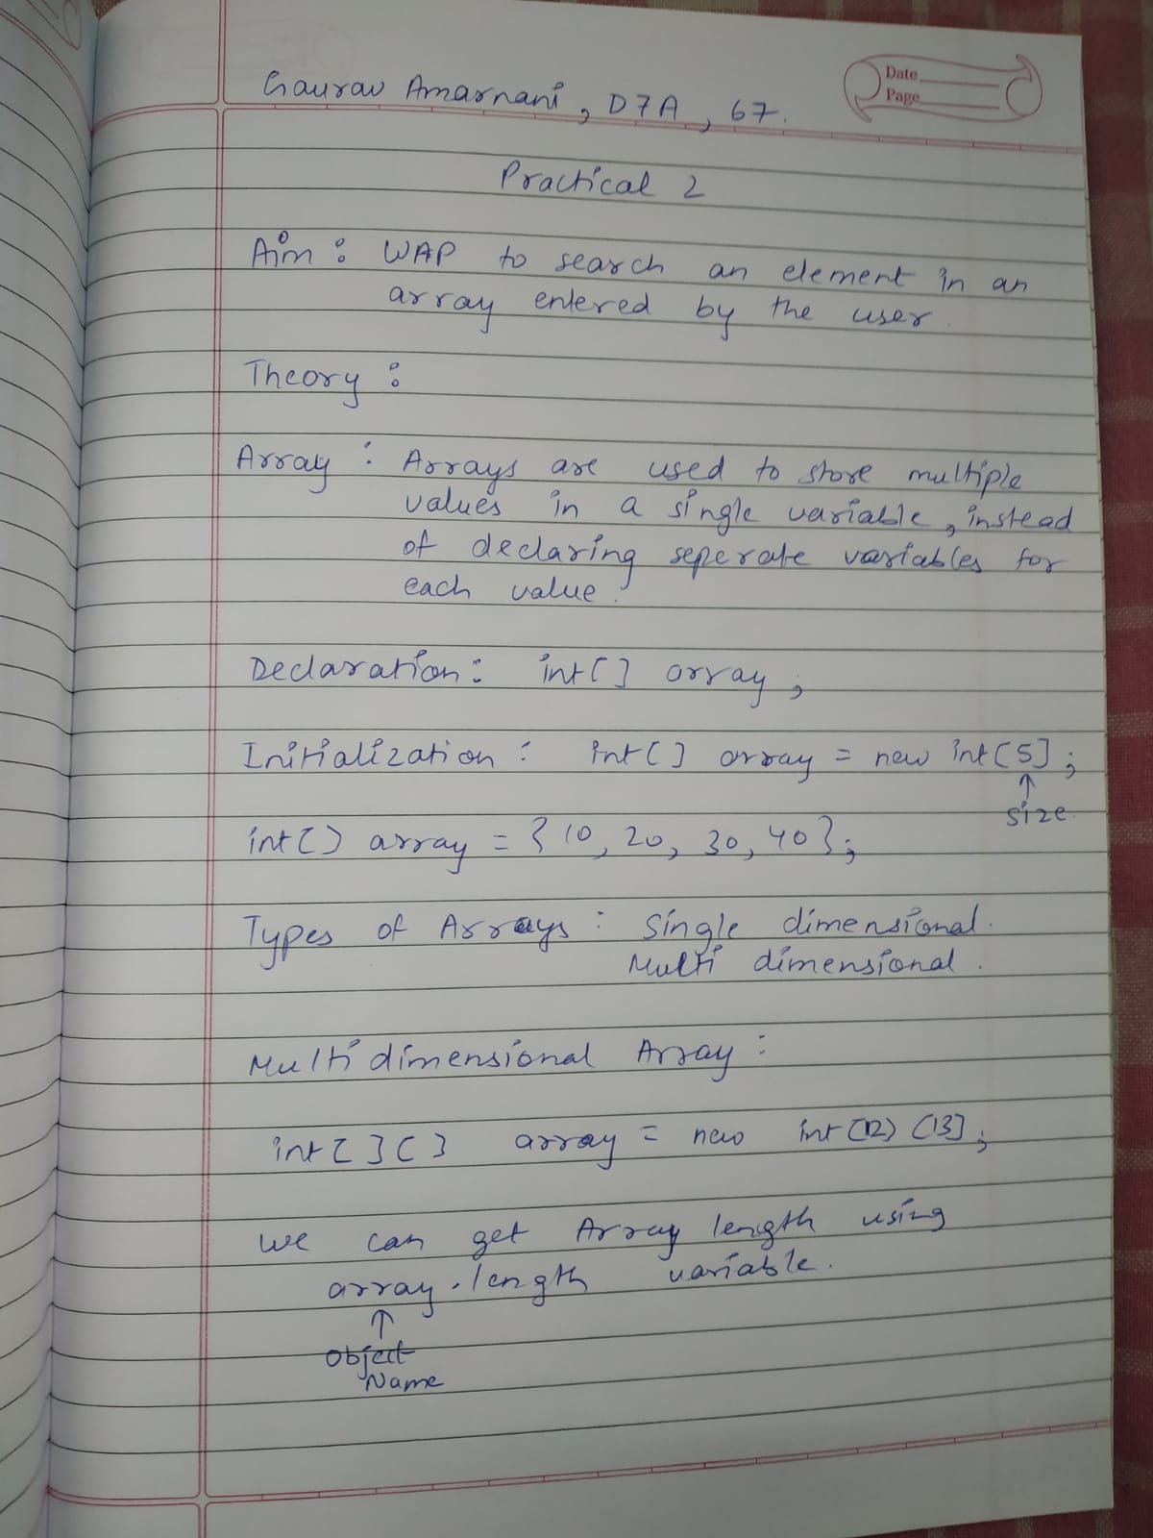

**Name: Gaurav Amarnani.**

**Roll No. 67, D7A.**

Program:

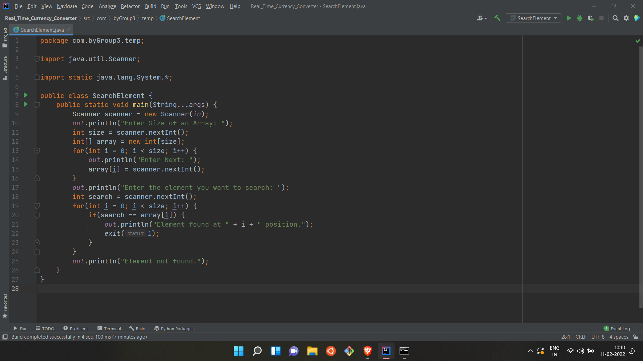

Output:

